Revelation

**The Vision** **of the Beast**

**Rev. 13:1 “And I stood upon the sand of the sea, and saw a beast rise up out of the sea, having seven heads and ten horns, and upon his horns ten crowns, and upon his heads the name of blasphemy.”**

The first part of the verse goes along with chapter twelve (**“And he stood”**).

Then we commence the new thought **“And I saw”**:

John is seeing in the spirit this vision of **“The Beast”:**

1. **The Location It Came From:**
2. No particular place or people. “A beast rise up out of the sea”
3. Sea has to do with nations, and peoples (**Rev. 17:15**).
4. The fact it “rose up”, came into power.
5. **The description of “The Beast”:**
6. “Having Seven Heads”:

**Rev. 17:9-10** says, “The seven heads are seven mountains … And … there are seven kings”. Mountains in the scriptures, we are made to understand, are kingdoms (**Psa. 30:7 - Jer. 51:25 - Dan. 2:25**). Therefore these are seven kingdoms – seven world ruling powers. This is a full revelation of “The Times of The Gentiles”, from beginning to end. Who are these Seven Kingdoms? History makes it plain who they are:

1. Assyria
2. Egypt
3. Babylon
4. Persia
5. Greece
6. Rome
7. And here we have the final kingdom; the kingdom of the anti-Christ.

In the 17th chapter we read:

1. **“…Five Are Fallen…”:**
2. Assyria
3. Egypt
4. Babylon
5. Persia
6. Greece

At this particular time John is beholding this scene, there has been five fallen.

1. **“…And One Is…”:**

Again, there was “one” in power at the time of John’s vision – there is no question as to what kingdom it was. The Roman Empire was still in rule and power at that time.

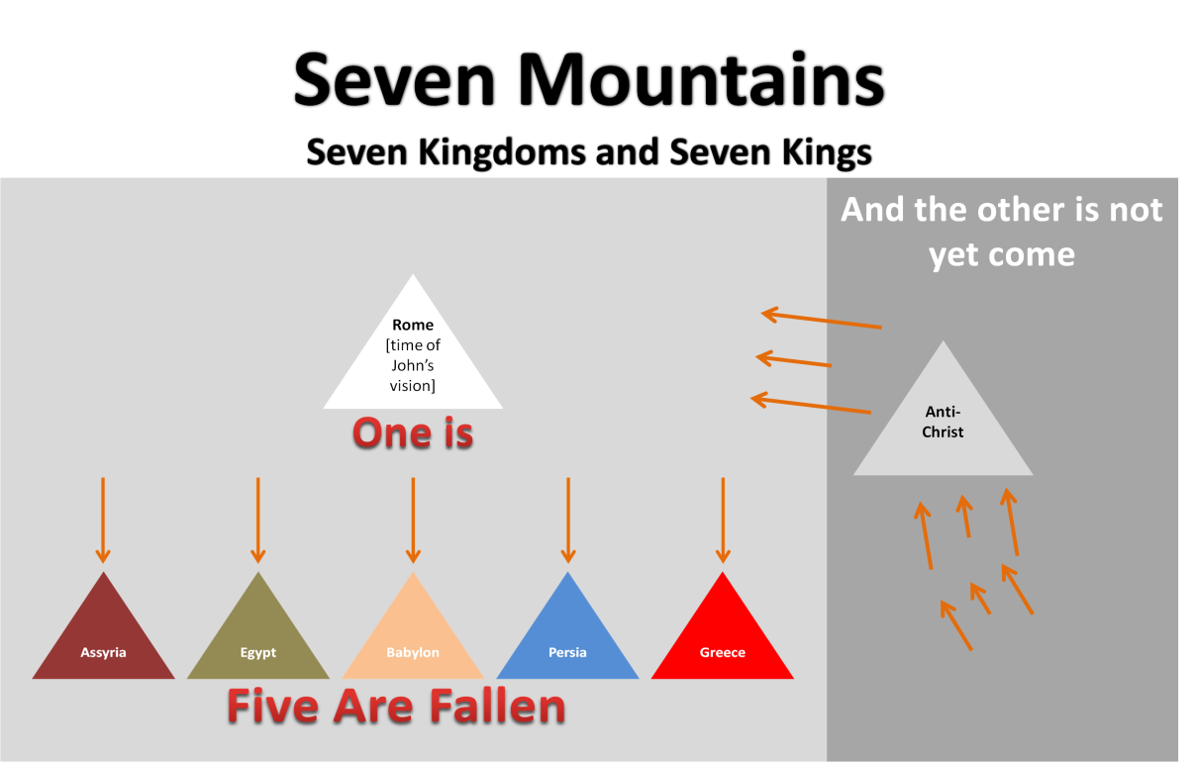

1. **“…And the other is not yet come…”:**

That is, the anti-Christ has not yet set up his kingdom. He is the seventh kingdom and he must continue a “short space”.

* He comes on the scene during the first part of the Tribulation and then in the middle of the tribulation he is slain with the Sword…
* and resurrected to life to be the eighth which is of the seventh.
* Rev 17:11: “And the beast that was, and is not, even he is the eighth, and is of the seven, and goeth into perdition”

1. “…And Ten Horns…”:

Dan. 7:24: “And the ten horns out of this kingdom are ten kings”

Rev. 17:12: “And the ten horns which thou sawest are ten kings”

These are not a description of the previous kings, but are the ten kings, the ruling powers, which will rise up after the Roman Empire.

**This is in agreement with Nebuchadnezzar’s dream, and Daniel’s vision.**

* Nebuchadnezzar saw a Great Image broken up into Four Sections and finally divided into ten toes.
* Babylon: the head
* Persia: the shoulders and breast
* Greece: the belly and thighs
* Rome: the thighs and legs and feet, then the ten toes; the ten horns of John’s vision

**Daniel’s vision was four wild beasts.**

* A lion
* A bear
* A leopard
* An indescribable beast; and coming out of this beast were ten horns

(Dan. 7:7)

**“And it had ten horns”:**

* + Comparing to the ten toes of Nebuchadnezzar’s dream and the ten horns of John’s vision.
  + However we see something in Daniels vision that is not seen in either Nebuchadnezzar’s dream or John’s vision.

**“There came up among them another little horn.”:**

* John sees:
  + The beast itself being the “Little Horn” that comes up among the ten.
* However Daniel sees:
  + There were three of the “First Horns plucked up by the roots.”
    - This would indicate that Daniel saw a more advanced stage than what John declares.
      * John saw ten horns in the 17th chapter of Revelations. This indicates that he saw them before any of them were plucked up.
        + Furthermore at this stage they have not received their Kingdom (Rev. 17:12).

The fact that John saw ten horns in the 17th Chapter of Revelations indicating the he saw them before any of them were plucked up…

Declares

“And the other that has not yet come”

At the time that John was seeing that the anti-Christ “had not yet come” into power, was possibly just before or at, the beginning of the Tribulation.

“Which received no kingdom as yet; but receive power as kings one hour with the beast.” The first part of the Tribulation hour.

1. “And Upon His Horns Ten Crowns”

They have now received their crowns and John sees the time of the ten kings reigning with the anti-Christ during the first part of the Tribulation.

For after this John sees the seventh head wounded and resurrected.

However John makes no more mention of the ten kings, but Daniel declares that three of them fall before the anti-Christ when he is resurrected from death.

**“Another Beast”**

Rev. 13:11-

1. “ ‘I beheld another beast’ coming out of the earth;”
   * A beast in prophecy represents a “kingdom” (Dan. 7:23).
     + This is a kingdom -
2. “coming out of the earth”
   * “A beast coming out of the ‘sea’ ” is representative in prophecy as such rising amid “many peoples and multitudes”, a highly populated area (Rev. 17:15).
     + “The waters which thou sawest ,… are peoples, and multitudes, and nations, and tongues”
     + To come out of the “earth”
       - Earth: country, ground-land.

A nation springing up out of the “Earth”

* Instead of overthrowing other powers to establish itself, this nation would rise in territory previously unoccupied.
  + Yet it is a “beast” – it has a beast nature.

“Therion” – a wild beast – a dangerous animal.

Our country sprang up from the ground. It has been said by a prominent author… “Like a silent seed we grew into an empire”

1. “And he had two horns like a lamb”
   * Horns are representative of a ruler
     + Dan. 7:24 “And the ten horns out of this kingdom are ten kings
   * “He (the beast- the nation) had two horns” The constitution was set up in such a way that the state was sovereign and also the Church was sovereign.
   * The lamb-like horns indicated something of a spiritual nature.
     + The Founding Fathers – Spiritual leaders in Government as well as in the Church. George Washington was a praying man. This nation was at least lamb-like in nature in its foundation.
2. “And he spake as a dragon”
   * Speaking as a “dragon” is indicating there is a change in policy
   * The lamb-like horns and then the voice of a dragon indicate a real change in character and in policy.
   * Our civil and religious freedoms are fast being taken away.
   * Notice in verses 12-18
     + The dragon is beginning to speak.

Slowly our government is becoming a dictatorship instead of a free democracy - a government by the people - of the people - for the people. We are headed to a New World Order.

Ministers across the land, in an effort to stop national destruction, have moved millions of Christians to political action. The feeling is that something must be done. Leaders of the “Electronic Church” launched a campaign to arise 50 million Christians.

* + - Pat Robertson said: “Unless Christians desire a nation and a world, reordered to the humanistic/ hedonistic (pleasure is the good) model, it is absolutely vital that we take control, of the U.S. government, away from the Trilateral Commission and the Council of Foreign Relations.”
    - I am afraid it is too little, too late.
    - We need to be preparing ourselves to get out. We failed as a people to occupy till he comes.

**Topical Notes On the Beast**

**Why Is He Called The Beast In Revelations?**

He is wounded, and then raised, incarnated by the devil.

**What Is The Sign Of His Coming?**

There will be a falling away in the Church.

**Who Will Be Deceived?**

Rev. 13:8 – “And all that dwelt upon the earth shall worship him, whose names are not written in the book of life of the Lamb slain before the foundation of the world.”

**What Will Take Place Under His Reign?**

**What Will His Sign Or Emblem Be?**

666

**What Will Be The Final Outcome Of The Man Of Sin?**

Rev. 19:20 – “And the beast was taken and with him the false prophet that wrought miracles before him, with which he deceived them that had received the mark of the beast, and worshiped his image. These both were cast alive into the lake of fire burning with brimstone.”

**The Mark Of The Beast**

1. Instituted by the false prophet.

Rev. 13:16 – “And he causeth all, both small and great, rich and poor, free and bond, to receive a mark in their right hands, or in their foreheads.”

1. By Deception -

A wolf in sheep’s clothing. [vs, 11][vs. 14]

1. By Miracles –

[vs. 12-13]

1. By Coercion –

[vs. 15] “would not worship….should be killed.”

1. The Design of the Mark –

Rev. 13:16 – “And he causeth all….to receive a mark.”